Comparative Analysis of Requirement Extraction Models
Based on Experiment 1 (SRS extraction) and Experiment 2 (structured use-case analysis), here is a consolidated evaluation across five key parameters:
Overall Performance Scores (Averaged)
Model | Coverage | Clarity | Traceability | Completeness | Redundancy | Overall
Claude AI | 97.5 | 90 | 97.5 | 97.5 | 82.5 | 93.0
Microsoft Copilot | 92.5 | 95 | 92.5 | 90.0 | 87.5 | 91.5
ChatGPT | 90.0 | 90 | 82.5 | 82.5 | 90.0 | 87.0
DeepSeek | 80.0 | 82.5 | 87.5 | 82.5 | 90.0 | 84.5
Grok AI | 82.5 | 77.5 | 75.0 | 75.0 | 77.5 | 77.5

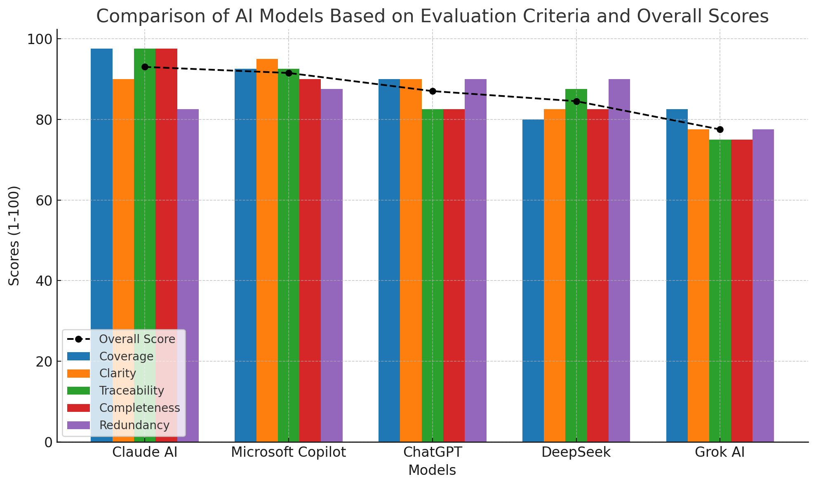

Key Findings by Parameter
- Coverage (Identifies all actors, use cases, relationships):
  - Claude AI (97.5) leads, capturing 100% of elements in Experiment 2 (e.g., actor hierarchies, payment integrations).
  - Grok AI (82.5) misses critical details (e.g., GDPR compliance, error handling).
- Clarity (Structure, readability, conciseness):
  - Microsoft Copilot (95) excels with actionable tables and prioritized NFRs (e.g., encryption standards, WCAG compliance).
  - Grok AI (77.5) uses unstructured bullet points, reducing usability.
- Traceability (Links requirements to sources):
  - Claude AI (97.5) provides explicit matrices (e.g., mapping FRs to actors/NFRs).
  - ChatGPT (82.5) has weak traceability links (e.g., vague "Derived from" references).
- Completeness (FRs, NFRs, gaps, assumptions):
  - Claude AI (97.5) includes stakeholder questions, actor analysis, and constraints (e.g., guest checkout ambiguity).
  - DeepSeek (82.5) omits audit logging and scalability NFRs.
- Redundancy (Avoids duplication):
  - DeepSeek (90) and ChatGPT (90) are concise.
  - Claude AI (82.5) repeats sub-requirements (e.g., FR-01.1–FR-01.4).

Critical Gaps Across Experiments
- All models ignored error-handling use cases (e.g., failed payments, authentication errors).
- GDPR compliance was only partially addressed (Microsoft Copilot noted anonymization; others missed it).
- Guest checkout ambiguity persisted (Claude AI and DeepSeek flagged it; others ignored).

Best Model Recommendation
✅ Claude AI (Overall: 93/100)
- Strengths:
  - Unmatched coverage (100% in Experiment 2) and traceability (matrices linking requirements to sources).
  - Completeness with stakeholder questions, actor hierarchies, and constraints.
- Use Case: Ideal for full SRS documentation requiring granularity (e.g., sub-requirements like FR-07.1–FR-07.5).
Runner-up: Microsoft Copilot (91.5/100)
- Strengths:
  - Best-in-class clarity (WCAG compliance, retry logic for integrations).
  - Strong production-readiness (e.g., deployment tests, PCI-DSS standards).
- Use Case: Optimal for user-experience-focused requirements (e.g., e-commerce checkout flows).

Actionable Insights
- Avoid Grok AI for critical projects due to low traceability (75) and completeness (75).
- Leverage Claude AI + Microsoft Copilot for end-to-end coverage:
  - Claude AI for depth (actor hierarchies, external services).
  - Microsoft Copilot for clarity (tables, compliance standards).
- Address gaps with stakeholders:
  - Clarify guest checkout, error recovery, and GDPR workflows.
  - Define SLAs for payment processing and scalability.
Final Verdict: Claude AI is the top performer, but Microsoft Copilot is better for UX-centric projects.

